**Week-10-Character Arrays and Strings**

**Reg no :241001159**

**Name : PADHMAVATHY.M**

**Q1)**

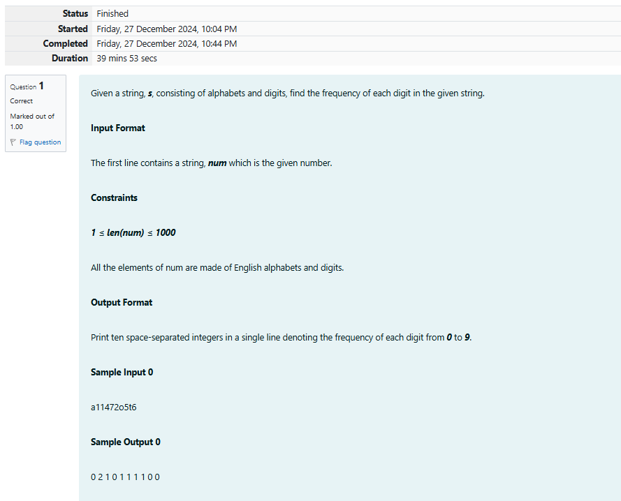

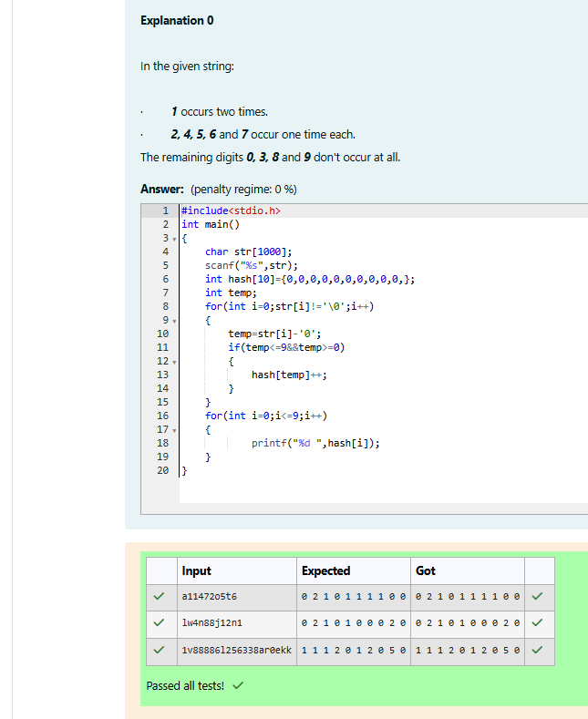

**Reg no : 241001159**

**Name : PADHMAVATHY.M**

**Q2)**

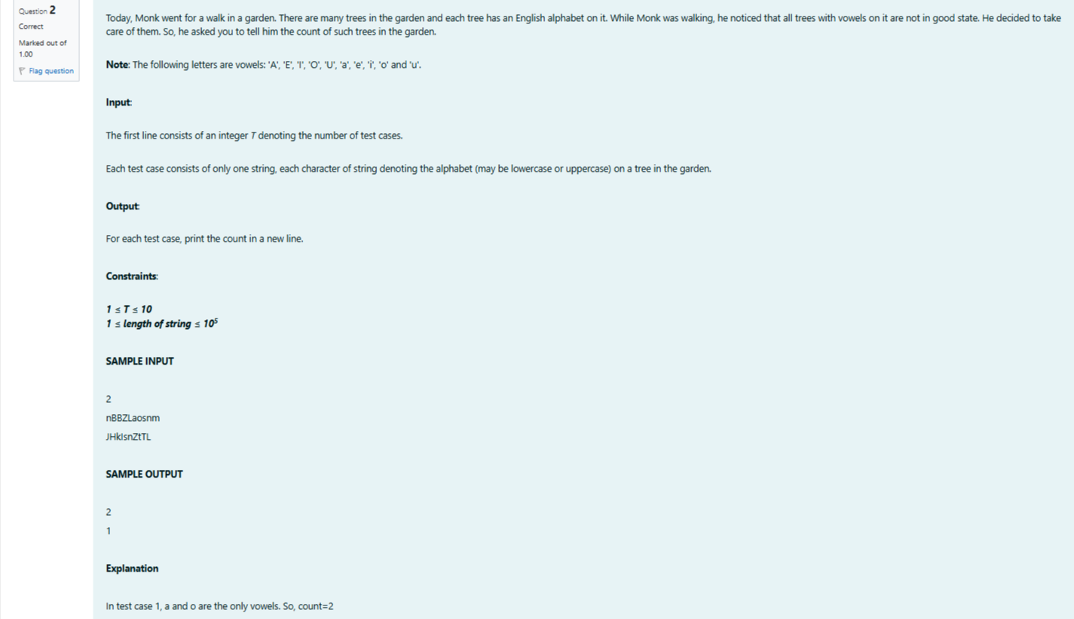

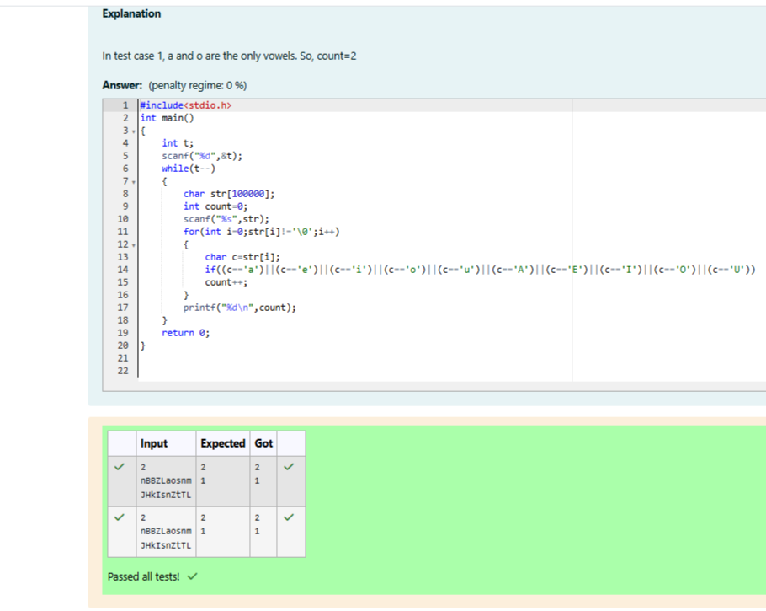

**Reg no : 241001159**

**Name : PADHMAVATHY.M**

**Q3)**

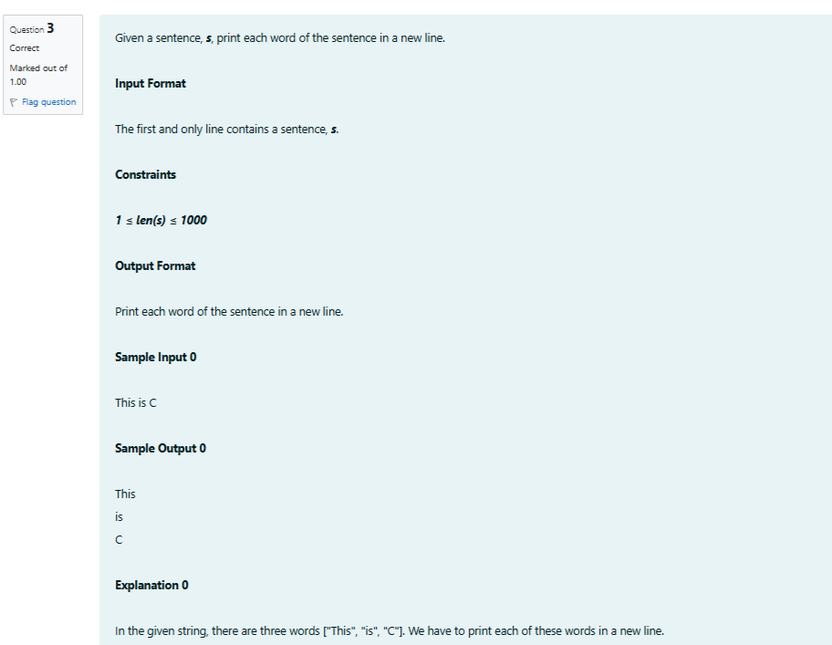

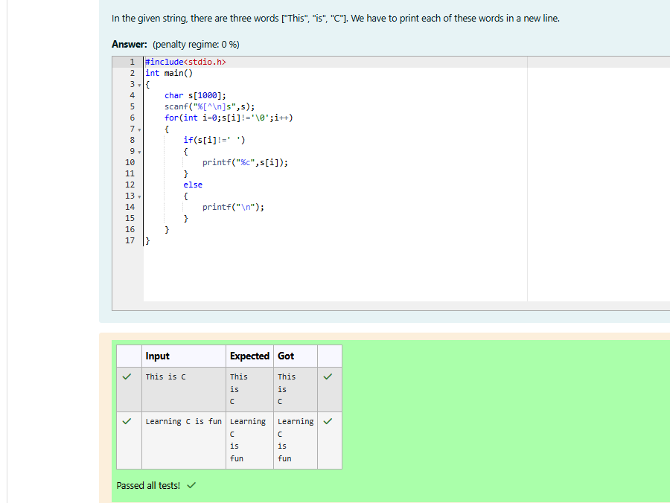

**Reg no : 241001159**

**Name : PADHMAVATHY.M**

**Q4)**



